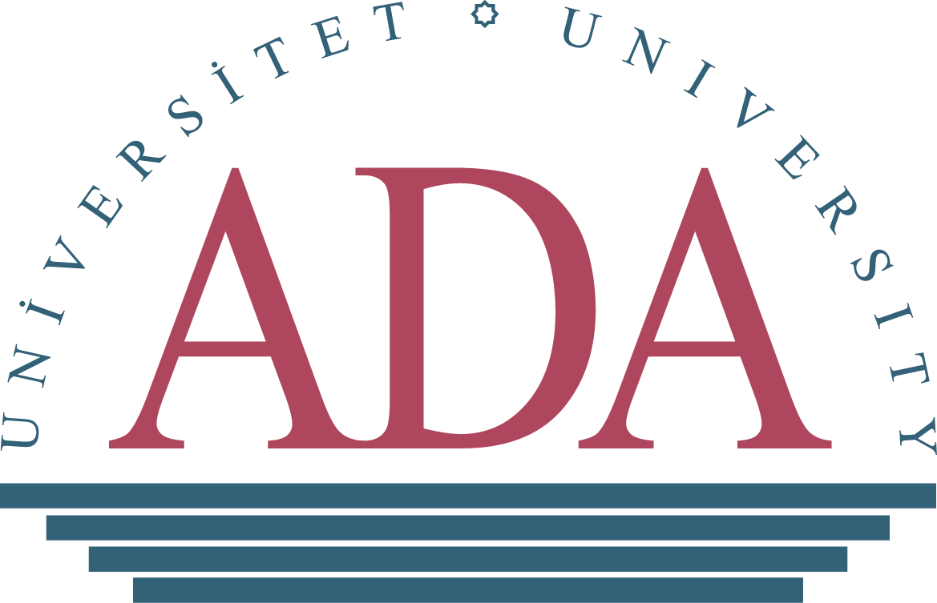

**CALL FOR PAPERS**

**ADA 2020- 5th International Education Conference**

***Education 2020 and Beyond: Looking into the Future***

ADA University in partnership with the Ministry of Education of Azerbaijan and U.S. Embassy in Azerbaijan is delighted to invite researchers and policymakers in the field of education to submit their research papers to and share their research findings at ***the ADA 2020 5th International Education Conference.***

ADA 2020 is a premier academic forum that will bring together scholars, policymakers, independent researchers, educational practitioners and students to meet and discuss latest trends, most recent developments and issues in the field of education. It will create grounds for conference participants to reflect on best practices, to explore solutions to common challenges facing the education sector in the technology-powered era.

Designed to address development prospects and key concerns in the education area, ADA 2020 Education Conference theme is revolved around the national strategic goals and targets reflected in the Strategic Roadmap on National Economy (2016), Education Development Strategy (2013), Development Concept: Azerbaijan 2020: Outlook for the Future (2012). In line with the areas raised in these policy documents, ADA Education Conference accepts proposals covering the following topics:

* Preschool Education and Early Childhood Development
* Primary and Secondary Education
* Inclusive and Special Education
* Vocational Education
* Teacher Education and Development
* ICT in Education
* Students in K-12 Education and Higher Education
* Higher, Adult, and Lifelong Education
* Teaching, Learning, Assessment, and Evaluation
* Teaching Infrastructure
* Education Policy and Finance
* Research and Institutional Development
* Leadership Issues in Education/ Educational Leadership: Best Practices, Challenges, and Suggestions
* Globalization and Internationalization of Education

The Conference is intended to be broad, encompassing panel discussions, presentations of research papers and poster sessions that build on the expansion of the parameters of knowledge production and educational practice in the process of national and international education development. Authors presenting at the conference get opportunity to have their full papers published in the conference proceedings.

*Criteria for paper submission*

Research proposals (both abstracts and full papers at a later stage) are accepted in ***Azerbaijani, English and Russian***. The length of abstract: **minimum 500** words with three key words.

*Important dates and deadlines*

Deadline for the submission of abstracts: January 31, 2020

Successful applicants notified: February 17, 2020

Deadline for the submission of full papers: April 27, 2020

Conference Registration Open – February 1, 2020

Deadline for the conference registration: June 5, 2020

Date of Pre-Conference Workshop: June 17, 2020

Date of Conference: June 18-19, 2020

*Submission*

Please submit your abstract, using and downloading the [abstract submission form](https://drive.google.com/file/d/1eHuietn6KatatgrgWfsIkwt7ipv6riZj/view?usp=sharing) by January 31, 2020 to ADA School of Education at [sel@ada.edu.az](mailto:sel@ada.edu.az). Please include “Abstract for ADA 2020 Education conference – Your Name” in the subject line of the e-mail.

Abstracts should include the following details: title of paper, full name(s), affiliation, current position, an email address, and at least 3 keywords that best describe the subject of your submission. Abstract submission must follow all general [guidelines](https://drive.google.com/file/d/12woFy4Ii6dLQgthqp283NKH2xCt6ih-e/view?usp=sharing) put forward by ADA University. Abstracts and full paper submissions will be evaluated by the Conference Research Committee, based on originality, technical/research depth, accuracy and relevance to conference theme. If abstract is accepted, author agrees to send full text paper, including results, tables, figures and references.

*Registration for the conference and fees*

Submission of your paper or proposal does NOT automatically register you for the conference itself. Everyone planning to attend the conference must complete the registration process. Online registration for the ADA 2020 5th International Education conference will be available in February 2020 at ADA University Conference webpage <http://edcon.ada.edu.az/>

The registration fee is **45 AZN** for Azerbaijani citizens**/ 80 AZN** for non-citizens.

*Included in the registration fee: admission to preconference workshops, conference sessions, plenaries, daily refreshment breaks, conference booklet etc.

Payment can be made online at <https://online.ada.edu.az/payment/>, *which will be activated on February 1, 2020 at ADA University Conference webpage*.

Payment via bank transfer can be made to ADA University AZN bank account. Bank account details information can be found at <https://drive.google.com/file/d/1gsSyrIPQvV7dIsFAdk94KKz7-cI--dpi/view?usp=sharing>

*Communication*

Questions can be directed to ADA University School of Education at [sel@ada.edu.az](mailto:sel@ada.edu.az) or 4373235 (ext.189 or ext. 417)